




LIBRARY MANAGEMENT SYSTEM

A PROJECT REPORT

Submitted by

SRI KARUNYA S S K

in partial fulfilment for the award of the course

CGB1221 – DATABASE MANAGEMENT SYSTEMS IN

DEPARTMENT OF COMPUTER SCIENCE AND ENGINEERING
(ARTIFICIAL INTELLIGENCE AND MACHINE LEARNING)


K. RAMAKRISHNAN COLLEGE OF ENGINEERING
(AUTONOMOUS) SAMAYAPURAM, TRICHY


ANNA UNIVERSITY CHENNAI 600 025

MAY 2026

LIBRARY MANAGEMENT SYSTEM

PROJECT FINAL DOCUMENT

Submitted by

SRI KARUNYA S S K (8115U24AM052)

in partial fulfilment for the award of the course

CGB1221 – DATABASE MANAGEMENT SYSTEMS IN
DEPARTMENT OF
COMPUTER SCIENCE AND ENGINEERING (ARTIFICIAL INTELLIGENCE AND MACHINE LEARNING)

Under the Guidance of Mr. P. NAGARAJ M.E.,
Department of Computer Science and Engineering
(Artificial Intelligence and Machine Learning)
K. RAMAKRISHNAN COLLEGE OF ENGINEERING



K. RAMAKRISHNAN COLLEGE OF ENGINEERING
(AUTONOMOUS)
ANNA UNIVERSITY, CHENNAI



K. RAMAKRISHNAN COLLEGE OF ENGINEERING (AUTONOMOUS)
ANNA UNIVERSITY, CHENNAI

BONAFIDE CERTIFICATE

Certified that this project report titled “LIBRARY MANAGEMENT SYSTEM” is the bonafide work of SRI KARUNYA S S K (8115U24AM052) who carried out the work under my supervision.

SIGNATURE SIGNATURE

Dr. B. KIRAN BALA M.E.,M.B.A.,Ph.D., Mr. P. NAGARAJ M.E.,

HEAD OF THE DEPARTMENT SUPERVISOR ASSOCIATE PROFESSOR, ASSISTANT PROFESSOR,
Department of Artificial Intelligence Department of Artificial Intelligence and Machine Learning, and Machine Learning,
K. Ramakrishnan College of K. Ramakrishnan College of
Engineering, (Autonomous) Engineering, (Autonomous)
Samayapuram, Trichy. Samayapuram, Trichy.

SIGNATURE OF INTERNAL EXAMINER SIGNATURE OF EXTERNAL EXAMINER

NAME: NAME:
DATE: DATE:



K. RAMAKRISHNAN COLLEGE OF ENGINEERING (AUTONOMOUS)
ANNA UNIVERSITY, CHENNAI

DECLARATION BY THE CANDIDATE

I declare that to the best of my knowledge the work reported here in has been composed solely by myself and that it has not been in whole or in part in any previous application for a degree.

Submitted for the project Viva-Voice held at K. Ramakrishnan College of Engineering on

SIGNATURE OF THE CANDIDATE

ACKNOWLEDGEMENT

I thank the almighty GOD, without whom it would not have been possible for me to complete my project.

I wish to address my profound gratitude to Dr.K.RAMAKRISHNAN, Chairman,
K. Ramakrishnan College of Engineering(Autonomous), who encouraged and gave me all help throughout the course.

I extend my hearty gratitude and thanks to my honorable and grateful Executive Director Dr.S.KUPPUSAMY, B.Sc., MBA., Ph.D., K. Ramakrishnan College of Engineering(Autonomous).

I am glad to thank my Principal Dr.D.SRINIVASAN, M.E., Ph.D.,FIE., MIIW., MISTE., MISAE., C.Engg, for giving me permission to carry out this project.

I wish to convey my sincere thanks to Dr.B.KIRAN BALA, M.E., M.B.A., Ph.D., Head of the Department, Artificial Intelligence and Machine Learning for giving me constant encouragement and advice throughout the course.

I am grateful to Mr.P.NAGARAJ, M.E., Assistant Professor, Artificial Intelligence and Machine Learning, K. Ramakrishnan College of Engineering (Autonomous), for his guidance and valuable suggestions during the course of study.

Finally, I sincerely acknowledged in no less terms all my staff members, my parents and, friends for their co-operation and help at various stages of this project work.

SRI KARUNYA S S K (8115U24AM052)



DEPARTMENT OF CSE (ARTIFICIAL INTELLIGENCE AND MACHINE LEARNING)
VISION
To become a renowned hub for AIML technologies to producing highly talented globally recognizable technocrats to meet industrial needs and societal expectation.

MISSION
Mission of the Department
M1 To impart advanced education in AI and Machine Learning, built upon a foundation in
Computer Science and Engineering.
M2 To foster Experiential learning equips students with engineering skills to tackle real-world problems.
M3 To promote collaborative innovation in AI, machine learning, and related research and development with industries.
M4 To provide an enjoyable environment for pursuing excellence while upholding strong personal and professional values and ethics.

PROGRAM EDUCATIONAL OBJECTIVES (PEO’s)
PEO1 Excel in technical abilities to build intelligent systems in the fields of AI & ML in order to find new opportunities.
PEO2 Embrace new technology to solve real-world problems, whether alone or as a team, while prioritizing ethics and societal benefits.
PEO3 Accept lifelong learning to expand future opportunities in research and product development.

PROGRAM SPECIFIC OUTCOMES (PSO’s)
PSO1 Expertise in tailoring ML algorithms and models to excel in designated applications and fields.

PSO2 Ability to conduct research, contributing to machine learning advancements and innovations that tackle emerging societal challenges.

PROGRAM OUTCOMES (POs)
Engineering students will be able to:

PO1 Engineering knowledge: Apply the knowledge of mathematics, science, engineering fundamentals, and an engineering specialization to the solution of complex engineering problems. PO2 Problem analysis: Identify, formulate, review research literature, and analyze complex engineering problems reaching substantiated conclusions using first principles of mathematics, natural sciences, and engineering sciences.
PO3 Design/development of solutions: Design solutions for complex engineering problems and design system components or processes that meet the specified needs with appropriate consideration for the public health and safety, and the cultural, societal, and environmental considerations.
PO4 Conduct investigations of complex problems: Use research-based knowledge and research methods including design of experiments, analysis and interpretation of data, and synthesis of the information to provide valid conclusions.
PO5 Modern tool usage: Create, select, and apply appropriate techniques, resources, and modern engineering and IT tools including prediction and modelling to complex engineering activities with an understanding of the limitations.
PO6 The Engineer and Society: Apply reasoning informed by the contextual knowledge to assess societal, health, safety, legal and cultural issues and the consequent responsibilities relevant to the professional engineering practice.
PO7 Ethics: Apply ethical principles and commit to professional ethics and responsibilities and norms of the engineering practice.
PO8 Individual and team work: Function effectively as an individual, and as a member or leader in diverse teams, and in multidisciplinary settings
PO9 Communication: Communicate effectively on complex engineering activities with the engineering community and with society at large, such as, being able to comprehend and write effective reports and design documentation, make effective presentations, and give and receive clear instructions.
PO10 Project management and finance: Demonstrate knowledge and understanding of the engineering and management principles and apply these to one’s own work, as a member and leader in a team, to manage projects and in multidisciplinary environments.
PO11 Life-long learning: Recognize the need for and have the preparation and ability to engage in
independent and life-long learning in the broadest context of technological change.

ABSTRACT

The Library Management System is a web-based application designed to automate and efficiently manage the daily operations of a library, replacing traditional manual methods with a digital solution that enhances accuracy, reduces paperwork, and saves time. The system provides essential functionalities such as user registration, secure login authentication, book management, and book issue and return processes. It is developed using standard web technologies including HTML, CSS, and JavaScript for the frontend, PHP for the backend, and MySQL as the database for storing and managing data in a structured manner. The system maintains records of users, books, and transactions while ensuring data integrity and minimizing redundancy through normalization. Users can easily search for books, check availability, and perform borrowing or returning operations through a simple and user-friendly interface. An admin module is also included, allowing administrators to add, update, or delete book records and monitor user activities effectively. The application supports full CRUD (Create, Read, Update, Delete) operations, enabling dynamic data handling throughout the system. Overall, the project demonstrates the practical application of database management and web development concepts, providing a reliable, scalable, and efficient solution for managing library resources in educational institutions and small organizations.

ABSTRACT WITH POs AND PSOs MAPPING

ABSTRACT | POs MAPPED | PSOs MAPPED
The Library Management System is a web- based application designed to manage and automate library operations efficiently. The system supports user registration, secure login, book search, issue and return functionality, and an admin panel for managing library resources and monitoring activities. It is built using a relational database management system (RDBMS) to handle user data, book records, transaction details, and activity history effectively. The system aims to provide an organized and user-friendly platform for accessing and managing library services. Key features include CRUD operations on books and user records, role-based access for users and administrators, responsive design for multi-device support, and secure session handling to protect user data. | PO1-3 PO2-3 PO3-3 PO4-3 PO5-3 PO6-3 PO7-3 PO8-3 PO9-3 PO10-3 PO11-3 | PSO1 – 3  PSO2 – 3
Note: 1- Low, 2-Medium, 3- High

TABLE OF CONTENTS
APTER |  | TITLE | PAG
No. |  |  | No.
 |  | ABSTRACT | viii
 |  | LIST OF ABBREVIATIONS | xii
 |  | LIST OF FIGURES | xiii
1 |  | INTRODUCTION | 1
 | 1.1 | Objective | 1
 | 1.2 | Scope of the Project | 2
 | 1.3 | Overview of the System | 3
 | 1.4 | Importance of DBMS in library systems | 5
 | 1.5 | Technologies Used | 7
2 |  | PROJECT METHODOLOGY | 9
 | 2.1 | Requirement Analysis | 9
 | 2.2 | Entity-Relationship (ER) Diagram | 10
 | 2.3 | Relational Schema | 11
 | 2.4 | Normalization Process | 12
 | 2.5 | System Architecture Overview | 12
3 |  | MODULE DESCRIPTION | 14
 | 3.1 | Admin Management Module | 14
 | 3.2 | Book Management Module | 15
 | 3.3 | Member Management Module | 15
 | 3.4 | Transaction Management Module | 16
 | 3.5 | Search & Filter Module | 16
 | 3.6 | Dashboard and Analytics Module | 17
4 |  | DATABASE IMPLEMENTATION | 18
 | 4.1 | Table Creation Scripts | 18
 | 4.2 | Constraints and Relationships | 20

CH E

 | 4.3 | Backup & Recovery Considerations | 21
5 |  | RESULTS AND DISCUSSION | 22
 | 5.1 | Performance Analysis | 22
 | 5.2 | Observations and Interpretations | 23
6 |  | CONCLUSION AND FUTURE WORK | 25
 | 6.1 | Summary of Outcomes | 25
 | 6.2 | Future Scope and Enhancements | 26
7 |  | APPENDIX | 28
 |  | APPENDIX A – Source Code | 28
 |  | APPENDIX B - Screenshots | 33
 |  | REFERENCES | 37

LIST OF ABBREVIATIONS

S. NO. | ACRONYM | ABBREVIATION
1 | CRUD | Create, Read, Update, Delete
2 | CSS | Cascading Style Sheets
3 | DBMS | Database Management System
4 | HTML | Hyper Text Markup Language
5 | ID | Identification
6 | ISBN | International Standard Book Number
7 | LMS | Library Management System
8 | OTP | One-Time Password
9 | SQL | Structured Query Language
10 | UI | One-Time Password

LIST OF FIGURES

FIGURE NO | TITLE | PAGE NO.
2.2.1 | Entity Relationship | 10
2.3.1 | Relational Schema | 11
2.5.1 | System Architecture | 13
B.1 | Login Page | 33
B.2 | Library Analytics Dashboard | 33
B.3 | Vendor Login Page | 34
B.4 | Vendor Page | 34
B.5 | Member Page | 35
B.6 | Books Page | 35
  - Issue Receive Page 36
  - Publisher Page 36

CHAPTER 1 INTRODUCTION

  - OBJECTIVE

The primary objective of the Library Management System project is to design and develop a user-centric web application that automates and simplifies the management of library operations. In the current digital age, managing library records manually is time- consuming and prone to errors. This system aims to provide a structured and efficient environment for handling books, members, and transactions digitally.

The system is developed with the goal of implementing all essential CRUD (Create, Read, Update, Delete) functionalities for managing books, user records, and issue-return activities. It ensures that administrators can log in securely, add new books, update or delete existing records, and monitor all library data efficiently. It also facilitates easy access to information through features like global search and dashboard analytics.

Furthermore, the system includes an admin module to provide complete control over all operations. Administrators are given the authority to manage book details, member records, authors, publishers, and transaction history. They can also update or remove incorrect data, ensuring accuracy and consistency in the system.

Security is also a key concern, and the objective includes implementing secure authentication methods to prevent unauthorized access. The system is designed with scalability in mind, making it easy to extend with additional features like fine calculation, report generation, or multi-user access in future iterations.

SCOPE OF THE PROJECT

The Library Management System is designed to serve as a lightweight yet functional application tailored for managing library resources efficiently. The scope of the project is broad and flexible, making it suitable for educational institutions, small organizations, and personal libraries.

At its core, the system allows administrators to log in and manage all library data within a secure and interactive interface developed using Streamlit and SQLite. Once authenticated, users can perform standard CRUD operations—Create, Read, Update, and Delete—on books, members, authors, and other records. The system also enables tracking of book issue and return transactions.
The system also supports administrative features. Admin users can monitor all records, update incorrect entries, and maintain data consistency. They can manage user- related data, book details, and transaction history, ensuring smooth functioning of the library system.
The scope of the project includes multiple functional modules:
    - Admin Module: Handles login, authentication, and system control
    - Book Management Module: Allows adding, editing, viewing, and deleting book
records.
    - Member Management Module: Manages member details and contact information.
    - Transaction Module: Tracks book issue and return details.
From a technical perspective, the project integrates a frontend developed using Streamlit with backend processing in Python and a structured database using SQLite to store all records securely. It ensures that data operations are efficient, consistent, and reliable by applying DBMS principles such as normalization and referential integrity.
This project is not limited to a single use case and can be adapted for schools, colleges, and organizations. It covers both current features and future enhancements, making it useful as a learning model as well as a practical application.

OVERVIEW OF THE SYSTEM

The Library Management System is a full-stack web application that enables administrators to manage, organize, and maintain library resources through an intuitive interface integrated with a structured database. The system is built using Streamlit for the frontend, Python for backend processing, and SQLite as the database, offering a seamless and efficient data management experience.
The platform operates in a simple client-based architecture, where users interact with the system through a web interface, which communicates with the backend to fetch or store data in the database. It primarily supports administrative users who are responsible for managing all library operations and maintaining records.
The core functionalities of the system include the following.

User Login and Authentication: Administrators can log in securely using valid credentials. Once authenticated, they gain access to the dashboard where they can manage all library data efficiently.
Book Management: The system allows administrators to add new books, edit existing book details, update information, or delete records. Each book record includes details such as book name, price, status, author, publisher, and library information.
Data Display: All records are displayed in an organized tabular format, allowing easy viewing and management of data. Users can interact with tables and update records dynamically.
Search Functionality: The system includes a global search feature that allows users to quickly find books by entering keywords, improving efficiency and saving time.
Transaction Management: The system maintains records of book issue and return activities, ensuring proper tracking of transactions between members and the library.

Admin Dashboard: The dashboard provides an overview of all database tables using analytics and metric cards, helping administrators monitor system data effectively.
User Interface (UI): The UI is designed to be simple, clean, and responsive. It ensures smooth navigation and provides interactive components such as forms, tables, and dashboards, making the system easy to use.
Backend Functionality: The backend handles application logic, data validation, database connectivity, and execution of SQL queries. It processes user inputs, stores data securely, and retrieves it when required.
Database Layer: The database consists of structured tables such as Books, Members, Authors, Publishers, Vendors, Employees, and Issue_Receive. Relationships between these tables are maintained using foreign keys, ensuring data integrity and consistency. The database is normalized to reduce redundancy and improve performance.
Security Features: Security mechanisms such as login authentication, input validation, and controlled access are implemented to protect data and prevent unauthorized usage.
Overall, the Library Management System provides a complete environment for managing library operations digitally. It focuses on usability, efficiency, and secure data handling, making it a practical solution for educational institutions and organizations.

IMPORTANCE OF DBMS IN LIBRARY SYSTEMS
A Database Management System (DBMS) is a vital component of any dynamic application, and its importance is particularly significant in data-intensive systems like a Library Management System. The system involves a continuous flow of data such as book records, member details, author information, transaction history, and timestamps. Managing this large volume of data in a reliable, organized, and secure manner is made possible through the use of a DBMS.
The key role of the DBMS in this project is to provide a structured way to store, retrieve, update, and manage all library-related data. Each piece of information such as a book record, member profile, or transaction entry is stored in database tables with defined relationships and constraints. By enforcing data integrity rules like primary keys and foreign keys, the DBMS ensures consistency in data storage and eliminates duplication or invalid entries.
Major benefits of DBMS in the Library Management System include the following.

All data such as book details, member records, and transaction history are stored in properly designed tables. SQL queries can be used to retrieve specific books, member-related data, or transaction details efficiently.
The system involves relationships such as one-to-many and many-to-one, for example one member can borrow multiple books and one book can be issued multiple times. These relationships are implemented using foreign keys, ensuring that the database reflects real-world interactions accurately.
By defining data types and constraints such as NOT NULL and UNIQUE, the DBMS ensures that invalid or redundant data is not stored in the system.

Sensitive data and system access are controlled using authentication mechanisms, ensuring that only authorized users can perform operations like updating or deleting records.
In case of unexpected failures, the DBMS ensures reliable data storage and supports recovery mechanisms to prevent data loss.
As the number of books and users increases, the DBMS can handle large volumes of data efficiently. Indexing and optimized queries help maintain system performance.
The system can support advanced features such as search functionality, filtering, and reporting by using SQL queries and database operations.
The database is normalized to reduce redundancy and improve performance. Proper schema design ensures faster query execution and efficient resource utilization.
In summary, the DBMS serves as the backbone of the Library Management System, enabling it to function smoothly and efficiently. It ensures that all data-related operations such as book management, member tracking, and transaction handling are performed reliably and securely. Without a robust DBMS, the system would face challenges in maintaining data consistency, security, scalability, and performance.

TECHNOLOGIES USED

The Library Management System is developed using a combination of frontend, backend, and database technologies. Each layer of the application, including presentation, logic, and data storage, is built using tools that are efficient, reliable, and easy to use. These technologies work together to deliver a responsive and fully functional system.
The main technologies used in this project are categorized as follows.

Front-End Technology

Streamlit is used to build the user interface of the application. It provides an interactive environment where users can easily navigate through dashboards, forms, and tables. It simplifies the development process and creates a clean and responsive design.

Back-End Technology

Python is used as the backend programming language. It handles application logic, user input processing, data validation, and communication with the database. It ensures smooth functioning of the system.
Authentication mechanisms are implemented to provide secure login functionality. Only authorized users can access and manage the system.

Database Management System

SQLite is used as the database to store all system data such as books, members, authors, and transactions. It is lightweight, easy to set up, and does not require a separate server, making it suitable for small-scale applications.

SQL queries are used to perform operations such as INSERT, SELECT, UPDATE, and DELETE. These queries enable efficient data management and retrieval.

Development Tools and Libraries

Visual Studio Code is used for writing and debugging the application code. It provides features such as syntax highlighting and error detection.
Python libraries such as Pandas are used for data manipulation and displaying records in tabular format within the application.

Optional Enhancements

The system can be extended with additional features such as report generation, fine calculation, and advanced search functionality.
The application can also be deployed on cloud platforms to make it accessible online for multiple users.
The chosen technology stack ensures performance, reliability, and ease of use for both developers and users. Together, these tools help in building a professional and efficient Library Management System suitable for real-world applications.

CHAPTER 2 LITERATURE SURVEY

This section reviews the design and development approach of the Library Management System, which follows a structured and systematic methodology to build a reliable, user-friendly, and secure application. The project is developed based on the principles of the Software Development Life Cycle (SDLC), focusing on requirement analysis, database design, modular implementation, and testing. This chapter explains the planning, analysis, and design aspects that form the foundation of the system.

REQUIREMENT ANALYSIS

The first step in developing the Library Management System is to identify both functional and non-functional requirements. These requirements define what the system should perform and the constraints under which it should operate.

Functional Requirements:
    - User Registration and Login
    - Adding, Updating, Deleting, and Viewing Book Records
    - Searching for books by title, author, or category
    - Book Issue and Return Management
    - Fine calculation for late returns
    - Admin functionalities: manage books, members, and transactions
    - Responsive navigation and data display

Non-Functional Requirements:
- Usability: Simple and user-friendly interface for librarians and user
- Performance: Fast search and quick retrieval of book and member details
- Security: Password encryption, access control, and protection against unauthorized access
- Scalability: Easily extendable to include features like online reservation or digital
library

  - Maintainability: Modular code structure and proper documentation for easy updates

ENTITY-RELATIONSHIP (ER) DIAGRAM

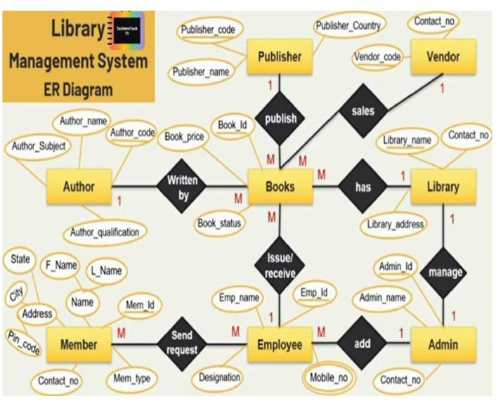

Figure 2.2.1 Entity Relationship

The ER Diagram illustrates how different entities in the Library Management System are connected. It provides a blueprint for structuring the database.

Main Entities:

- Admin: Stores admin details such as ID, username, password, and contact number
- Library: Contains library information such as library ID, name, and location
- Author: Stores author details like author code and name
- Publisher: Contains publisher details such as publisher code and name
- Vendor: Stores vendor details including ID, name, and contact
- Member: Includes member ID, name, and contact details

- Employee: Stores employee ID, name, and designation
- Books: Contains book ID, name, price, status, author code, publisher code, and library ID
- Issue_Receive: Includes transaction ID, book ID, member ID, issue date, and return date

Relationships:

- One author can write multiple books (one-to-many)
- One publisher can publish multiple books (one-to-many)
- One library can contain multiple books (one-to-many)
- One member can borrow multiple books (one-to-many)
- Books are linked with members through issue and return transactions.

RELATIONAL SCHEMA

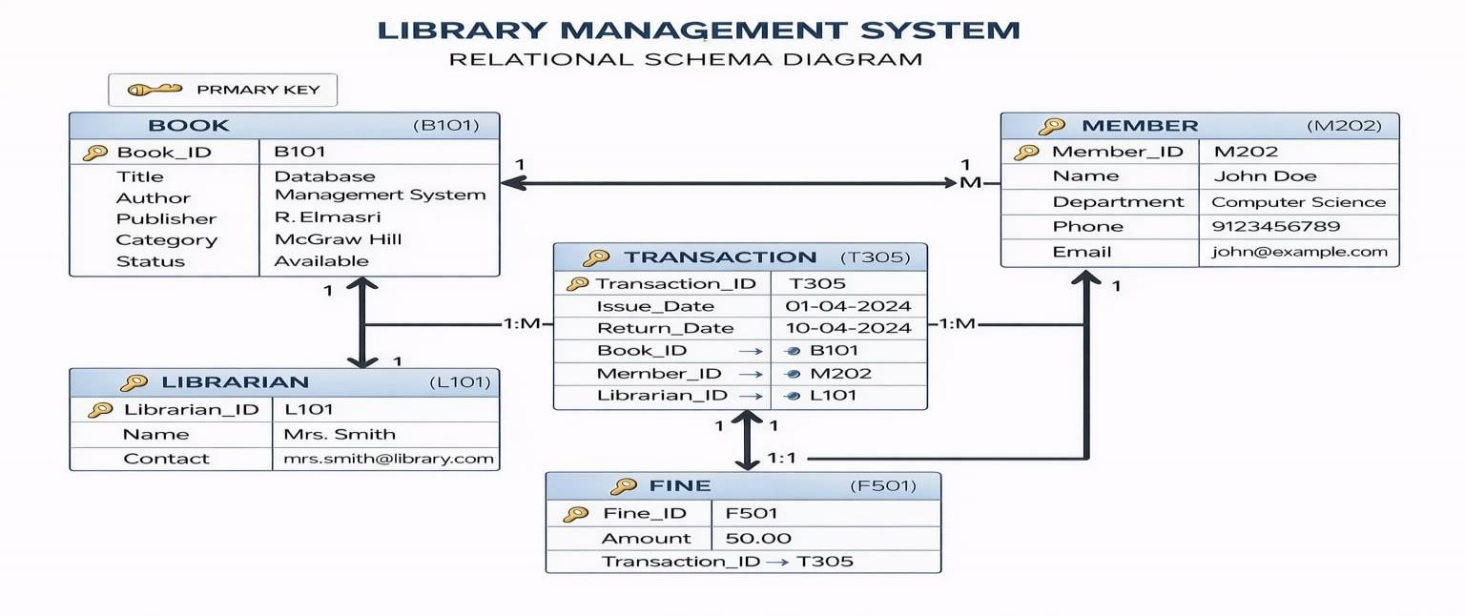

Figure 2.3.1 Relational Schema

Based on the ER diagram, the relational schema defines how data is organized into tables and how they are connected using primary and foreign keys. The system includes tables such as Admin, Library, Author, Publisher, Member, Books, and Issue_Receive,

where each table has a primary key to uniquely identify records. Relationships between tables are established using foreign keys, such as linking books with authors, publishers, and members through transactions. The schema is properly normalized to reduce redundancy and ensure data integrity.

NORMALIZATION PROCESS

Normalization is the process of organizing data in the database to reduce redundancy and improve efficiency. The Library Management System applies the first three normal forms to ensure a well-structured database. First Normal Form (1NF) ensures that all data is atomic and eliminates repeating groups. Second Normal Form (2NF) ensures that all non-key attributes are fully dependent on the primary key. Third Normal Form (3NF) removes transitive dependencies between non-key attributes. For example, author and publisher details are stored in separate tables instead of repeating them in the Books table, which avoids duplication and improves data consistency. This results in a clean, efficient, and scalable database design

SYSTEM ARCHITECTURE OVERVIEW

The architecture of the Library Management System follows a three-tier model:
- Presentation Layer (Frontend):
Built using Streamlit. It includes user interfaces for login, dashboard, book management, and data display.
- Application Layer (Backend):
Developed using Python. This layer processes user input, handles business logic, communicates with the database, and sends responses to the user interface.
- Data Layer (Database):
Managed using SQLite. It stores all persistent data including books, members, authors, publishers, and transaction records.

The system performs operations such as:
- Adding and managing book records
- User login authentication
- Searching books
- Managing issue and return transactions
- Updating and deleting records
Security features like authentication, input validation, and controlled access are included across all layers.
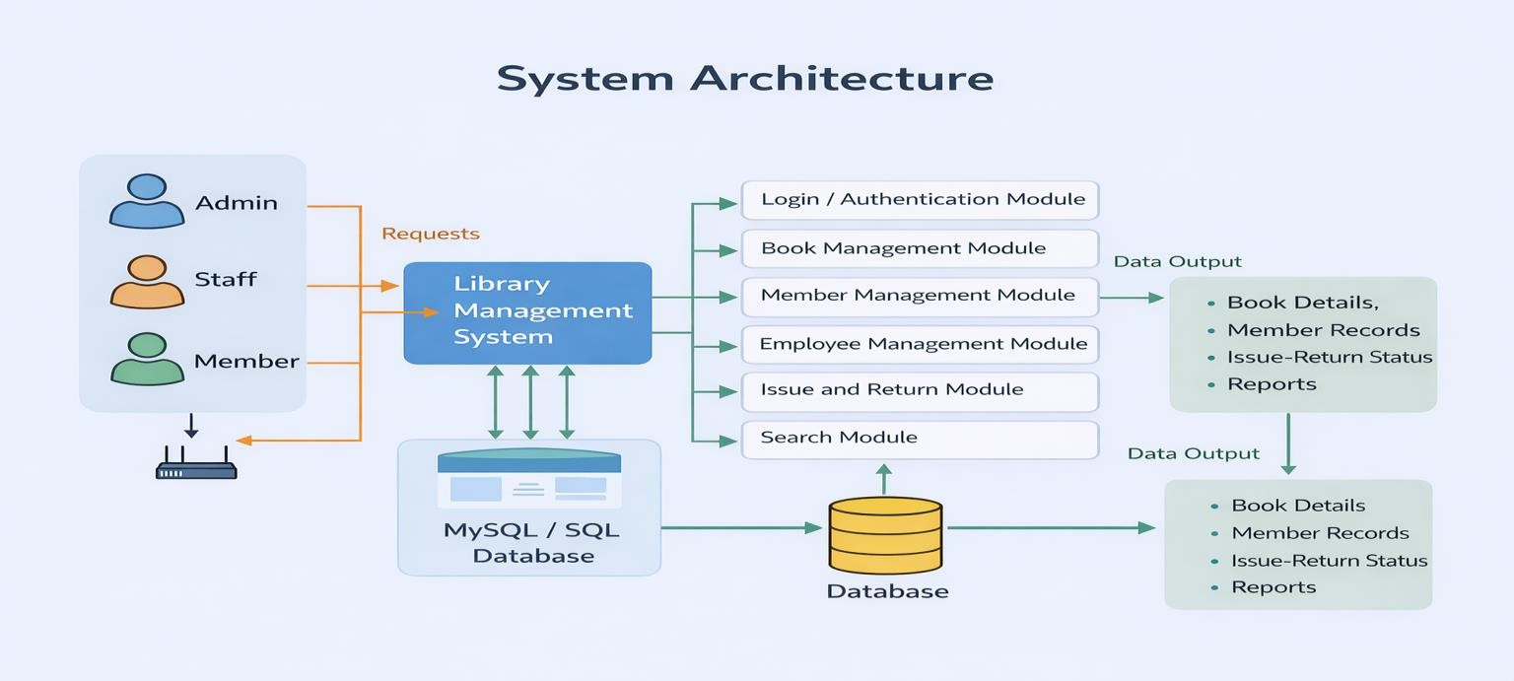

Figure 2.5.1 System Architecture

The methodology adopted for the Library Management System ensures a balance between functionality, performance, and maintainability. Through proper requirement analysis, schema design, normalization, and layered architecture, the project establishes a strong foundation for building a robust, secure, and user-friendly system.

CHAPTER 3 PROJECT METHODOLOGY

The Library Management System is structured as a modular application where each component is responsible for a specific functionality. Adopting a modular design helps in achieving separation of concerns, maintainability, and scalability. This chapter describes each major module in detail, explaining their roles, features, and the way they interact with other parts of the system.

ADMIN MANAGEMENT MODULE
The Admin Management Module handles all functionalities related to administrator access, such as login, logout, session handling, and access control. It plays a vital role in authentication and authorization, ensuring that only authorized users can access the system features.

Key Features:
    - Admin Login: Allows administrator to log in using username and password.Credentials are validated securely.
    - Login/Logout: Maintains user sessions and allows secure logout.
    - Access Control: Restricts unauthorized access to the system.
    - Authentication Security: Ensures only valid users can access admin dashboard.

Functionality Flow:
- Admin enters login credentials.
- Input is validated and checked with database records.
- On successful login, a session is initiated.
- Access to system features is granted based on authorization.

BOOK MANAGEMENT MODULE
This is the core functional module of the system. It allows administrators to create, view, update, and delete book records. It also supports displaying books in an organized format.

Key Features:
    - Book Addition: Admin can add new books with details such as name, price, author, publisher, and status.
    - Edit and Delete: Admin can update or delete book records.
    - Display: All books are retrieved from the database and displayed in tabular format.
    - Status Management: Books can be marked as Available or Issued.

Functionality Flow:
- Admin selects add book option and enters details.
- Book data is stored in the database.
- Books are fetched and displayed in the system.
- Edit or delete options are available for managing records.

MEMBER MANAGEMENT MODULE
This module manages member details and helps maintain records of users who borrow books.

Key Features:
    - Member Registration: Admin can add member details such as name and contact number.
    - Update and Delete: Member records can be modified or removed.
    - Display Members: All members are displayed in a structured format.

Functionality Flow:
- Admin enters member details.
- Data is stored in the database.
- Member records are displayed for management.

TRANSACTION MANAGEMENT MODULE
This module handles book issue and return operations, ensuring proper tracking of transactions.

Key Features:
    - Issue Book: Books are issued to members.
    - Return Book: Return details are updated in the system.
    - Date Tracking: Issue date and return date are maintained.
    - Transaction Records: All transactions are stored for reference.

Functionality Flow:
- Admin selects book and member.
- Issue details are stored in the database.
- On return, return date is updated.
- Transaction records are maintained.

SEARCH AND FILTER MODULE
This module improves user experience by allowing quick searching and filtering of records.

Key Features:
    - Keyword Search: Allows searching books using book name.
    - Filter Options: Records can be filtered easily.
    - Dynamic Results: Results are displayed instantly.

Functionality Flow:
- User enters search keyword.
- Database query retrieves matching records.
- Results are displayed instantly.

DASHBOARD AND ANALYTICS MODULE
This module provides an overview of system data using metrics and summaries.

Key Features:
    - Data Overview: Displays number of books, members, and transactions.
    - Interactive Dashboard: Shows data using metric cards.
    - Monitoring: Helps admin track system performance.

Functionality Flow:
- System retrieves data from database.
- Counts and summaries are calculated.
- Dashboard displays the information.

Each module in the Library Management System is independently responsible for a crucial functionality that contributes to the overall system. These modules are interconnected and operate as a complete system to deliver a smooth, efficient, and secure experience. The modular design allows easy maintenance and future enhancements such as advanced analytics and reporting features.

CHAPTER 4 DATABASE IMPLEMENTATION
A robust and well-structured database is the backbone of any application. In the Library Management System, the database plays a critical role in storing, organizing, and retrieving data such as book records, member details, and transaction information. This chapter explains how the database is designed and implemented, including table structures, relationships, constraints, and considerations for backup and recovery.

TABLE CREATION SCRIPTS
The system uses a relational database management system such as SQLite to store structured data. The following tables form the core of the database:
✅ 1 Admin Table
sql
Copy code
CREATE TABLE IF NOT EXISTS Admin (
admin_id INTEGER PRIMARY KEY AUTOINCREMENT,
username TEXT NOT NULL, password TEXT NOT NULL, contact_no TEXT
);
    - Purpose: Stores administrator details such as username, password, and contact number.
✅ 2. Library Table
Sql

CREATE TABLE IF NOT EXISTS Library (
library_id INTEGER PRIMARY KEY AUTOINCREMENT,
library_name TEXT NOT NULL, location TEXT
);

      - Purpose: Stores library information.

✅ 3. Author Table
sql
Copy code
CREATE TABLE IF NOT EXISTS Author (
author_code INTEGER PRIMARY KEY AUTOINCREMENT,
author_name TEXT NOT NULL
);
      - Purpose: Stores author details.

✅ 4. Publisher Table
sql
Copy code
CREATE TABLE IF NOT EXISTS Publisher (
publisher_code INTEGER PRIMARY KEY AUTOINCREMENT, publisher_name TEXT NOT NULL
);
Purpose: Stores publisher details.

✅ 5. Vendor Table
sql
Copy code
CREATE TABLE IF NOT EXISTS
Vendor (
vendor_id INTEGER PRIMARY KEY AUTOINCREMENT,
vendor_name TEXT NOT NULL,
contact TEXT
);
        - Purpose:Stores vendor details.

✅ 6.Member Table
sql
Copy code
CREATE TABLE IF NOT EXISTS
Member (
member_id INTEGER PRIMARY KEY AUTOINCREMENT,
member_name TEXT NOT NULL,
member_contact TEXT
);

CONSTRAINTS AND RELATIONSHIPS
Implementing primary keys, foreign keys, and constraints ensures that the database maintains data integrity, avoids redundancy, and enforces logical connections between tables.
    - Primary Keys:
Each table contains a primary key to uniquely identify records, such as admin_id, book_id, member_id, and transaction_id.
    - Foreign Keys:
Foreign keys establish relationships between tables. For example, author_code and publisher_code in the Books table link to Author and Publisher tables. The book_id and member_id in the Issue_Receive table connect transactions with books and members.
    - Constraints:
NOT NULL constraints ensure that essential fields such as book name and memberdetails are always provided.
UNIQUE constraints prevent duplicate entries where required. Default values such as book status ensure consistency.
Relationships between tables maintain proper linkage and data consistency.

BACKUP AND RECOVERY CONSIDERATIONS
Ensuring data safety and reliability is essential for any system. The Library Management System includes backup and recovery strategies to prevent data loss due to system failures or errors.

Backup Strategies:
Regular backups of the database file are maintained to avoid data loss. Data can be exported periodically into formats such as CSV for external storage. Optional cloud storage can be used for secure backup storage.

Recovery Strategies:
In case of failure, the database can be restored from backup files. Transactions can be managed to ensure consistency of data. Future enhancements may include automated backup systems and version tracking.

The database implementation in the Library Management System follows best practices of database design, normalization, and relational modeling. It ensures secure storage of records, reliable data handling, and efficient transaction management. By enforcing constraints, defining relationships, and implementing backup strategies, the system provides a strong foundation for long-term usage, data safety, and scalability.

CHAPTER 5 RESULTS AND DISCUSSION

After the successful development and implementation of the Library Management System, the system was thoroughly tested to evaluate its functionality, performance,and usability. This chapter presents the results of these evaluations and discusses how effectively the system meets its objectives, along with possible improvements.

PERFORMANCE ANALYSIS
The performance of the Library Management System was evaluated based on key aspects such as response time, database operations, user interface responsiveness,
and overall system reliability.

Frontend Performance:
    - The Streamlit-based interface is responsive and user-friendly.
    - Navigation between dashboard, tables, and forms is smooth and efficient.
    - Data display using tables and dashboards is clear and easy to understand.
    - Input forms for adding and editing records work without delays.

Backend Processing:
    - CRUD operations (Create, Read, Update, Delete) for books, members, and other
records execute correctly without errors.
    - Login authentication system works properly with session handling.
    - Data validation ensures correct input before storing into the database.
    - Backend processing using Python ensures smooth interaction with the SQLite
database.

Database Operations:
    - SQL queries execute efficiently due to structured schema design.
    - Data insertion, updating, and deletion operations are consistent and reliable.

    - Foreign key relationships maintain proper connections between tables like Books,
Members, and Issue_Receive.
    - No data redundancy observed due to normalized database structure.

Security Measures:
    - Basic login authentication restricts unauthorized access.
    - Input validation prevents incorrect or invalid data entry.
    - Controlled access is implemented for sensitive tables like Vendor (with PIN
protection).
    - Session-based login ensures secure usage of the system.

Scalability (Initial Observation):
    - The system handled multiple records (books, members, transactions) efficiently
during testing.
    - Performance remained stable with increasing data entries.
    - Future improvements like indexing and optimization can enhance scalability further.

OBSERVATIONS AND INTERPRETATIONS

User Experience:
Positive Feedback:
- The system is simple and easy to use.
- Users can manage records without technical difficulty.
- Dashboard and search features improve usability and efficiency.

Challenges Observed:
- Users may require confirmation messages for critical actions like delete.
- Advanced search filters can further improve usability.

Admin Insights:
- Administrators can easily manage all records from a single dashboard.
- The system provides clear visibility of database tables and records.
- Analytics features can be improved for better insights (e.g., most issued books).

Functional Stability:
- All modules (book management, member management, transactions, dashboard)
function correctly.
- No major errors or crashes were observed during testing.
- Error handling ensures stable and consistent system behavior.

Visual and Layout Aspects:
- The user interface is clean, modern, and visually appealing.
- Use of customized CSS improves the overall look and feel.
- Dashboard metrics and tables enhance readability and data understanding.
- Responsive layout ensures smooth usage across different screen sizes.

Additional Observations:
- The system ensures efficient data handling with minimal delay during operations.
- Proper database design helps in maintaining data consistency and integrity.
- The application can be easily extended with new features such as report generation and notifications.
- Overall, the system demonstrates a balance between usability, performance, and
reliability, making it suitable for real-world library management applications.

CHAPTER 6 CONCLUSION AND FUTURE WORK

SUMMARY OF OUTCOMES

The performance of the Library Management System was evaluated based on key parameters such as system efficiency, accuracy of database operations, real-time responsiveness, and overall user experience. The system was tested under different scenarios to ensure reliability and correctness of operations.

Key Findings:

    - System Functionality: The application successfully implements all essential library operations including managing books, members, authors, publishers, vendors, and issue/return transactions. All CRUD operations (Create, Read, Update, Delete) function correctly and ensure smooth data handling.
    - Database Efficiency: The use of SQLite as the database provides a lightweight yet efficient data storage solution. Proper normalization, use of primary and foreign keys, and structured schema design help maintain data integrity and eliminate redundancy.
    - User Interface and Experience: The Streamlit-based interface is interactive, clean, and easy to navigate. Features such as dashboard metrics, editable tables, and structured forms enhance usability and make the system suitable even for non- technical users.
    - Search and Data Handling: The global search functionality allows users to quickly locate book records, improving system efficiency. Data retrieval operations are fast and accurate due to optimized queries.
    - System Reliability: The system performs consistently without crashes or unexpected behavior. Input validation and error handling ensure smooth execution of operations.

    - Overall System Outcome: The project successfully achieves its objective of digitizing library operations, reducing manual work, and improving accuracy and efficiency in managing records.

Limitations:

    - The system currently uses basic login authentication and can be enhanced with advanced security features such as password hashing and role-based access control.
    - Since SQLite is used, it is more suitable for small to medium-scale applications and may face performance limitations in large-scale deployments.
    - The application is designed for local usage and does not currently support multi-user access over a network or cloud environment.
    - Advanced features such as automated notifications and detailed analytics are not yet implemented.

FUTURE SCOPE AND ENHANCEMENTS

While the Library Management System fulfills its primary objectives, there is significant scope for further improvement and expansion. These enhancements can transform the system into a more powerful and scalable application.

Proposed Future Enhancements:

- Advanced Search and Filters: Implement detailed search options based on author name, publisher, category, and availability status for better data retrieval.
- Role-Based Access Control: Introduce multiple user roles such as admin, librarian, and member with controlled permissions.
- Cloud-Based Deployment: Deploy the application on cloud platforms to enable remote access and multi-user functionality.
- Fine Calculation System: Automate fine calculation for overdue books and maintain records of penalties.

- Barcode and QR Code Integration: Enable faster book issue and return processes using barcode or QR code scanning.
- Email and Notification System: Send automated notifications for due dates, overdue reminders, and system updates.
- Reports and Analytics Dashboard: Generate detailed reports such as most issued books, active members, and transaction statistics for better decision-making.
- Data Backup and Recovery: Implement automatic backup mechanisms to ensure data safety and recovery in case of system failure.
- Mobile Application Development: Extend the system into a mobile application using modern frameworks for better accessibility.
- Security Enhancements: Add encryption techniques, secure authentication methods, and audit logs to improve system security.
The modular and flexible design of the system makes it easy to integrate these features without major changes to the existing architecture. This ensures scalability and adaptability based on future requirements.

APPENDICES APPENDIX A SOURCE CODE
This section presents key source code snippets from the Library Management System developed using Python (Streamlit) and SQLite database. The system follows a modular approach for better organization and maintainability.

User Login Module

Purpose: Authenticates admin user and provides access to the system.
Python
if "login" not in st.session_state: st.session_state.login = False
if not st.session_state.login:
user = st.text_input("Username")
pwd = st.text_input("Password", type="password")

if st.button("SIGN IN"):
if user == "admin" and pwd == "123": st.session_state.login = True st.rerun()
else:
st.error("Invalid Credentials!")

Explanation:
- Accepts username and password
- Validates admin credentials
- Uses session state for login control

DATABASE CONNECTION MODULE
Purpose: Connects the application to SQLite database.

Python
def get_connection():
return sqlite3.connect(db_path, check_same_thread=False, timeout=30)

Explanation:
    - Establishes connection with SQLite database
    - Enables safe multi-thread operations

DASHBOARD MODULE
Purpose: Displays table-wise record count.

Python
conn = get_connection()
for i in range(0, len(tables), 4): cols = st.columns(4)
for j, t in enumerate(tables[i:i+4]):
count = conn.execute(f"SELECT COUNT(*) FROM {t}").fetchone()[0] with cols[j]:
st.metric(label=f"{t}", value=count) conn.close()

Explanation:
    - Retrieves count of records
    - Displays using metric cards
    - Helps monitor database

GLOBAL SEARCH MODULE
Purpose: Searches books dynamically.

Python
search_all = st.text_input("Search Book Name...")

if search_all:
conn = get_connection() res = pd.read_sql(
f"SELECT * FROM Books WHERE book_name LIKE '%{search_all}%'", conn
)
conn.close() st.dataframe(res)

Explanation:
    - Accepts search input
    - Uses SQL LIKE query
    - Displays matching results

VIEW & EDIT RECORD MODULE

Purpose: Displays and edits table data.

Python
conn = get_connection()
df = pd.read_sql(f"SELECT * FROM {selection}", conn) conn.close()
edited_df = st.data_editor(df, use_container_width=True)

Explanation:
    - Loads data into editable table
    - Allows dynamic modification

SAVE (UPDATE) MODULE
Purpose: Saves edited records into database.
Python
if st.button("SAVE CHANGES"): conn = get_connection()
edited_df.to_sql(selection, conn, if_exists="replace", index=False) conn.commit()
conn.close() st.success("Database Updated!")

Explanation:
    - Updates database with new values
    - Replaces existing table data

ADD RECORD MODULE
Purpose: Adds new data into tables.

Explanation:
Python
with st.form(f"add_{selection}", clear_on_submit=True): new_row = {}
for col in df.columns:
new_row[col] = st.text_input(f"Enter {col}")

if st.form_submit_button("ADD RECORD"): conn = get_connection()
cols_str = ", ".join(new_row.keys()) placeholders = ", ".join(["?"] * len(new_row))
conn.execute(
f"INSERT INTO {selection} ({cols_str}) VALUES ({placeholders})",
list(new_row.values())
)
conn.commit() conn.close()
st.success("Added Successfully!")

    - Takes user input
    - Inserts into database
    - Uses parameterized query

LOGOUT MODULE
Purpose: Logs out admin securely.
Python
if st.sidebar.button("Logout"): st.session_state.login = False st.rerun()

Explanation:
    - Clears session
    - Redirects to login page

APPENDIX B – Screenshots
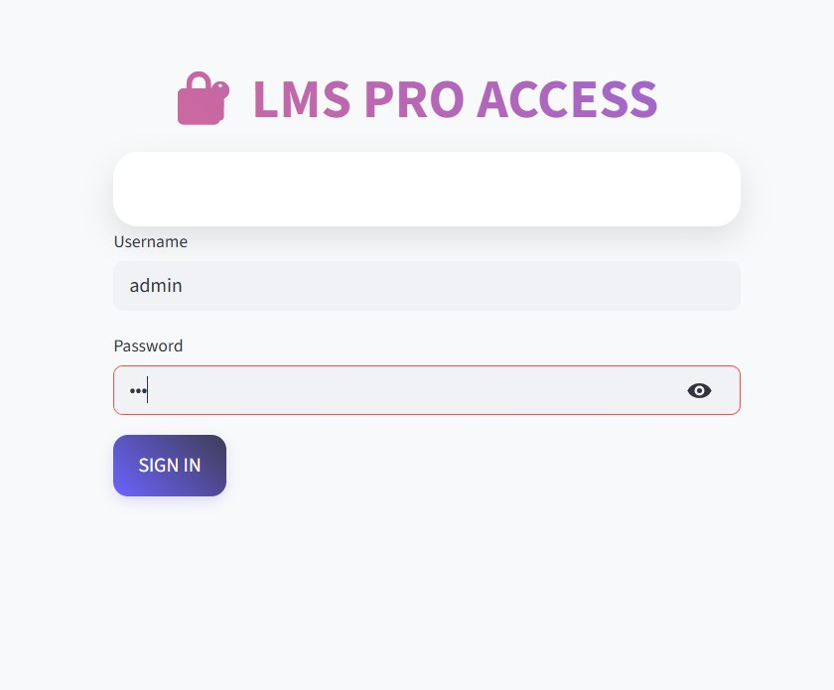

Figure B.1 LOGIN PAGE
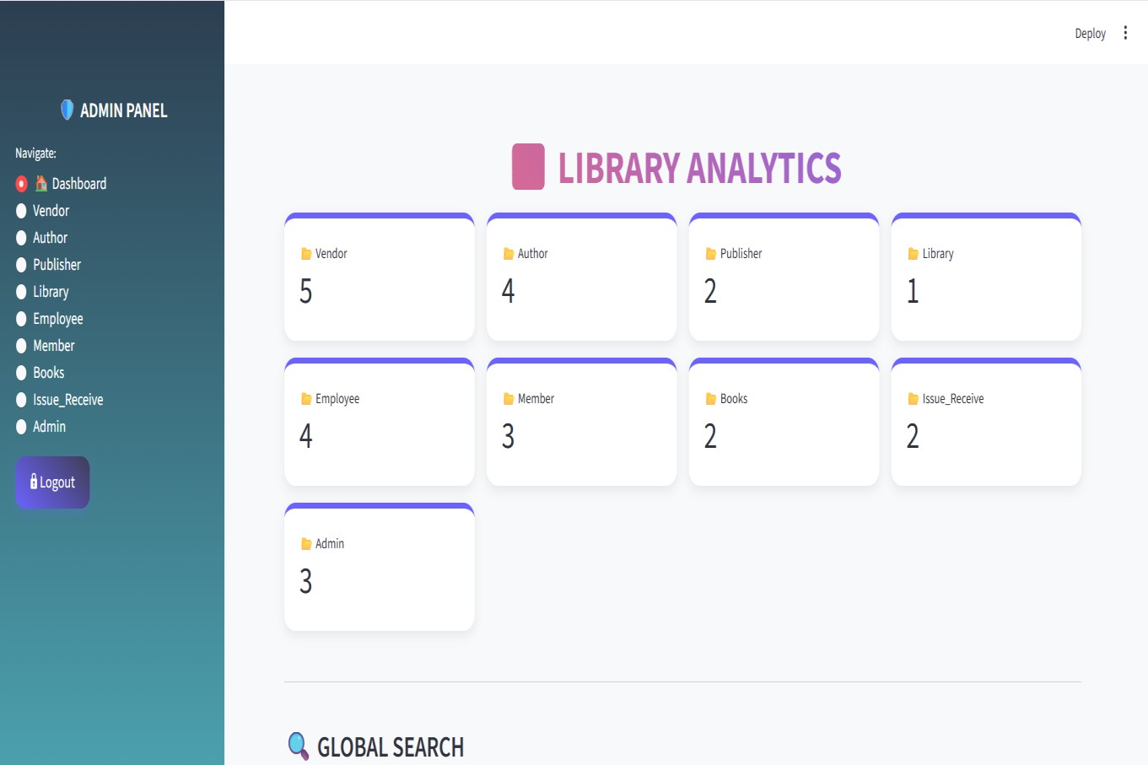

Figure B.2 LIBRARY ANALYTICS DASHBOARD

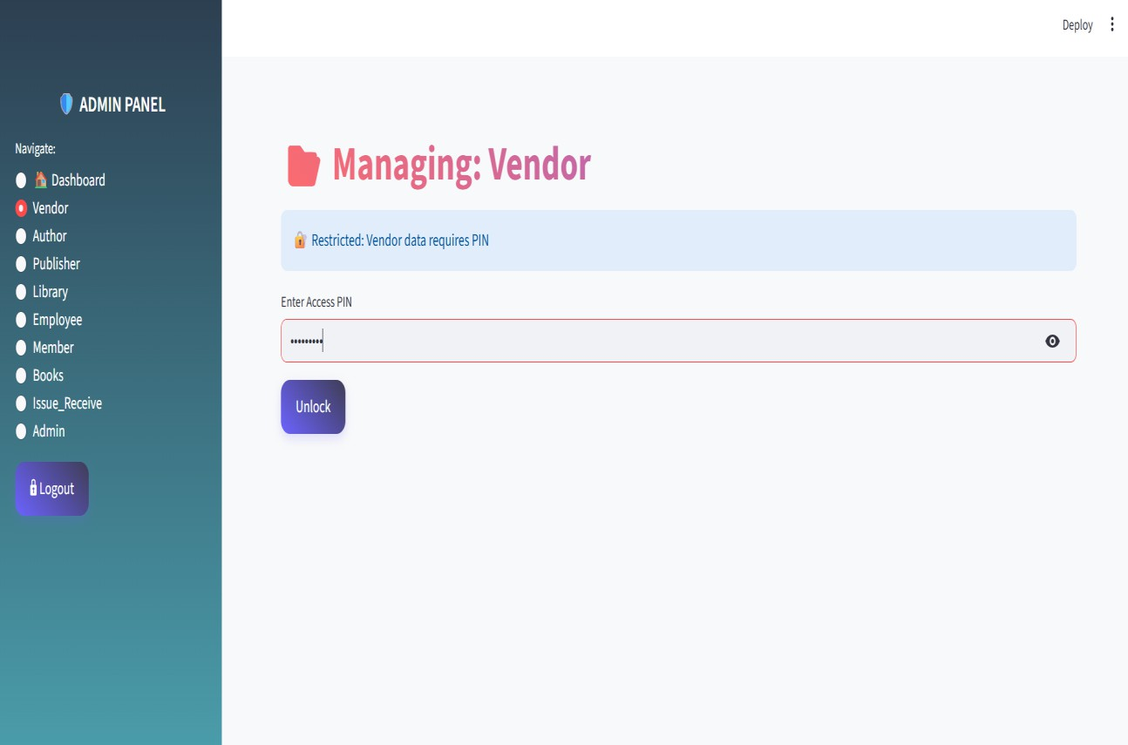

Figure B.3 VENDOR LOGIN PAGE
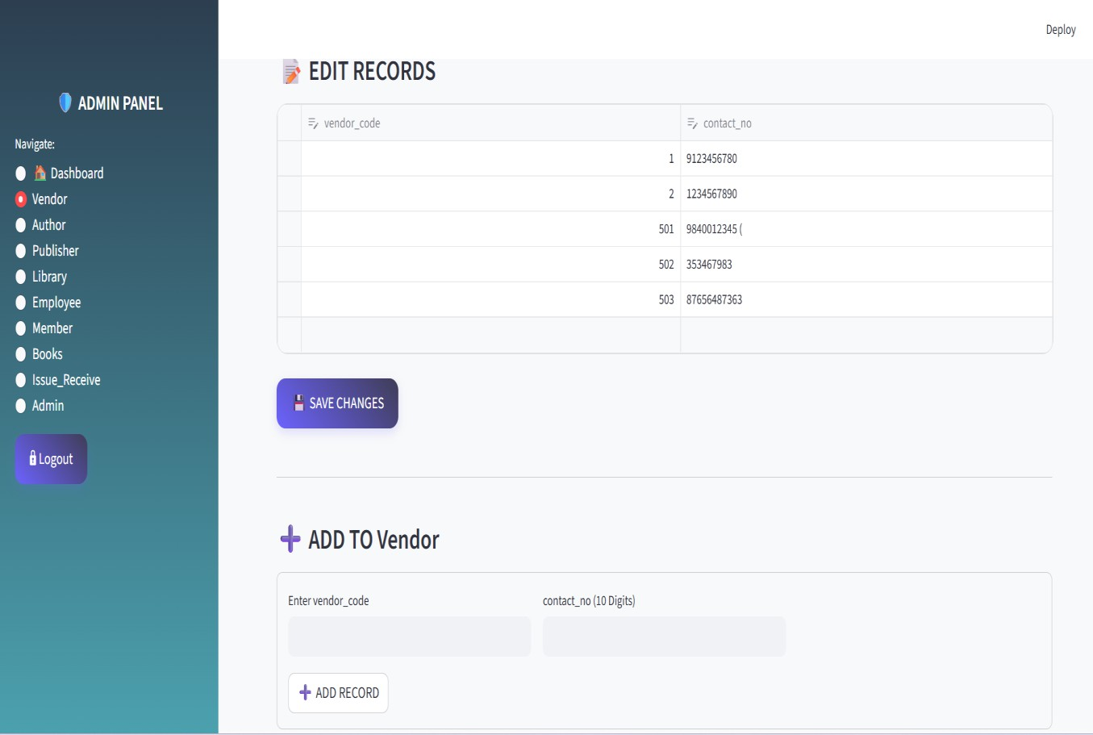

Figure B.4 VENDOR PAGE

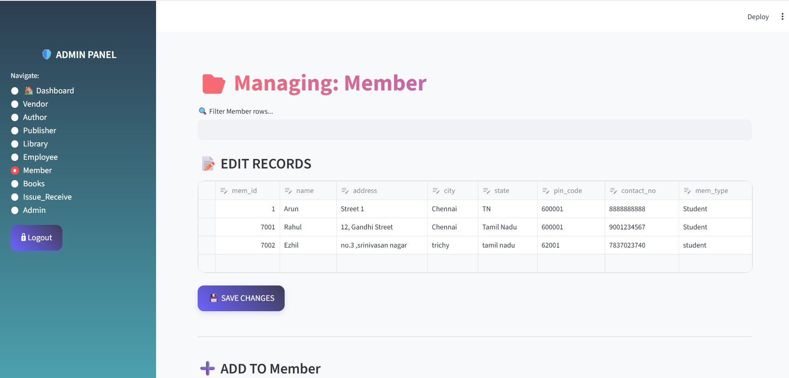

Figure B.5 MEMBER PAGE

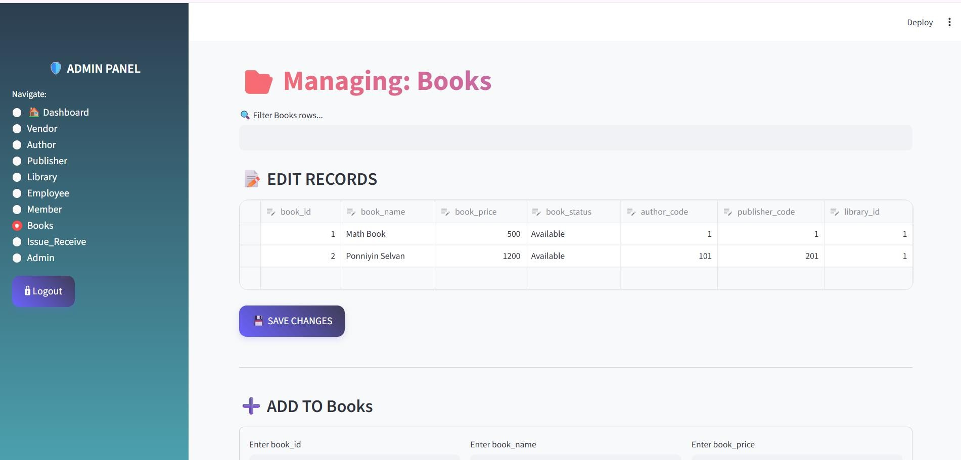

Figure B.6 BOOKS PAGE

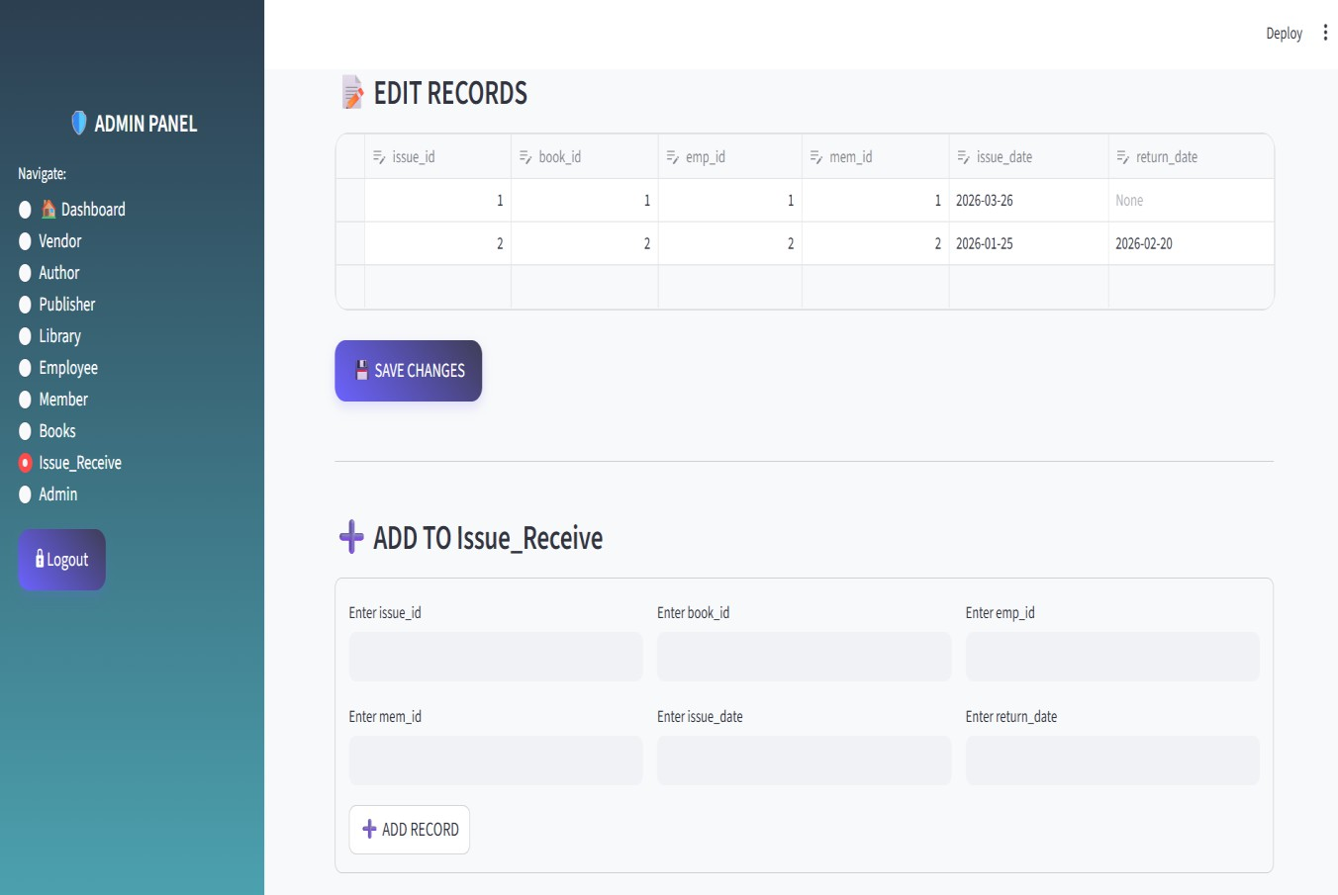

Figure B.7 ISSUE RECEIVE PAGE

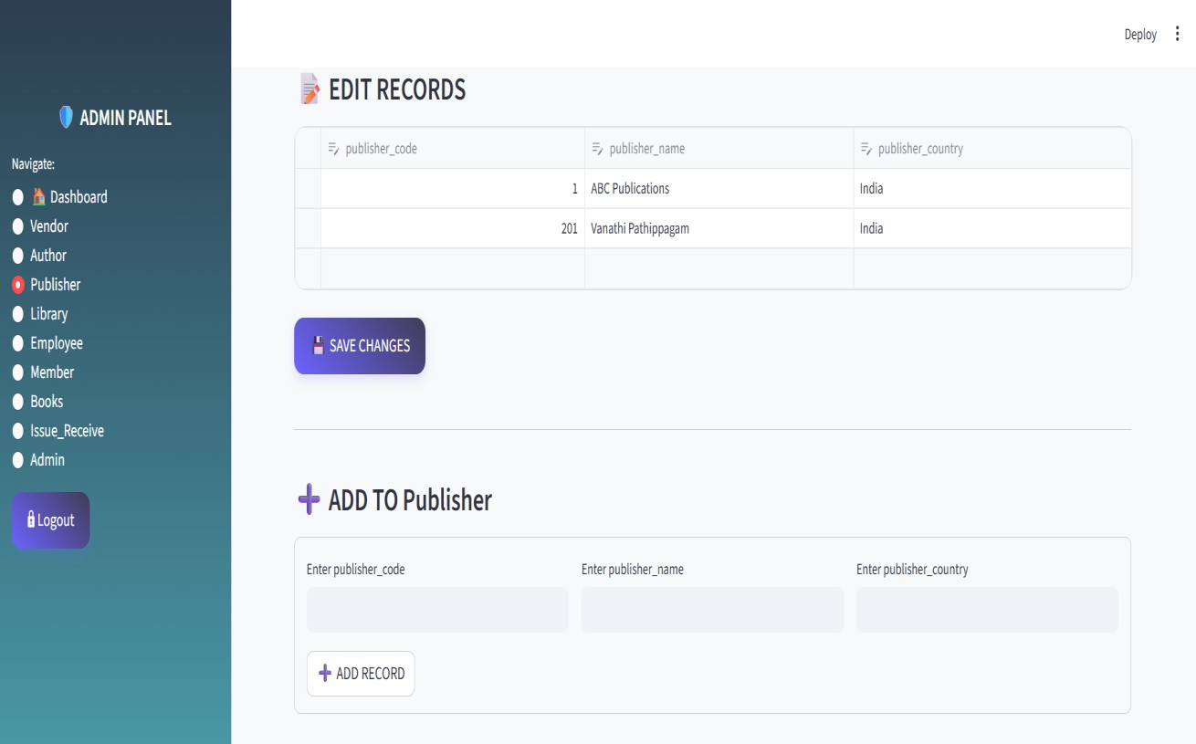

Figure B.8 PUBLISHER PAGE

REFERENCES

- Bhardwaj, V., & Garg, M. (2018). Development of a Web Content Management System in PHP. International Journal of Trend in Scientific Research and Development, 2(3), 1454–1456.

- Dhage, R., Deshbhratar, L., Harke, P., Sheikh, Z., & Bachwani, S. (2022). Review on Different Web Technology Stack. International Journal of Novel Research and Development, 7(12).

- Hidayat, C., Wahyudi, M., Miswanti, N., Fatmawan, R., & Eriana, E. S. (2024). Introduction to Web Programming: Building Simple Web Applications with PHP and MySQL. International Journal of Integrated Science and Technology, 2(11), 967–984.

- Iqbal, M., Supriyati, E., & Listyorini, T. (2026). Implementation of Bootstrap and PHP in a Web-Based Academic Violation Recording System. JRST (Jurnal Riset Sains dan Teknologi), 10(1).

- Khan, S., & Khanam, A. T. (2023). Study on MVC Framework for Web Development in PHP. International Journal of Scientific Research in Computer Science, Engineering and Information Technology, 9(4), 414–419.

- Nurfadilah, M. A., Faizah, N. M., & Rakryan, R. (2024). Designing the Indonesian Bird Lovers Website using Bootstrap PHP and MySQL with the Content Management System (CMS) Method. Journal Web Information Systems (JWIS), 1(1), 26–34.

- Sharma, R., & Singh, P. (2021). Web Development Using PHP and MySQL: A Review. International Journal of Computer Science and Mobile Computing, 10(5), 55–60.

- Sukardi, S., & Putra, T. I. (2022). Website E-Learning Menggunakan Web Responsive PHP dan Database MySQL. Jurnal Pedagogi dan Pembelajaran, 5(1), 42–49.

- Syahputra, M. Z., & Irawan, M. D. (2022). Application of Bootstrap in Building Fertilizer Inventory System Applications. Journal of Information Systems and Technology Research, 1(2), 42–50.

- Yadav, A., & Verma, S. (2023). Modern Web Application Development Using Bootstrap Framework. International Journal of Advanced Research in Computer Science, 14(2), 120–126.

